Project Plan Report

Team: 30 - Field Day

# Sprint Information

This section of the document contains information about the current and previous sprints for the project as documented in the tables below.

*Table 1- Current sprint details*

| Sprint Number | 1 |
| --- | --- |
| Sprint Start Date | Sep 25, 2022 |
| Sprint End Date | Oct 8, 2022 |
| Sprint Goal(s) | Conduct research and elicit initial requirements from the sponsor. |

*Table 2- Previous sprint details*

There is no previous sprint, this is the first sprint

# Project Snapshot

This section of the report contains a snapshot of the project’s current status. The project task board can be found at the following link:

<https://tree.taiga.io/project/jlnorma4-field-day-capstone-project/taskboard/sprint-1-2328>

## Previous Sprint’s Burndown Chart

There is no previous sprint, this is the first sprint.

## Current Sprint’s Burndown Chart

The following figure is a screenshot of this sprint’s burndown chart.

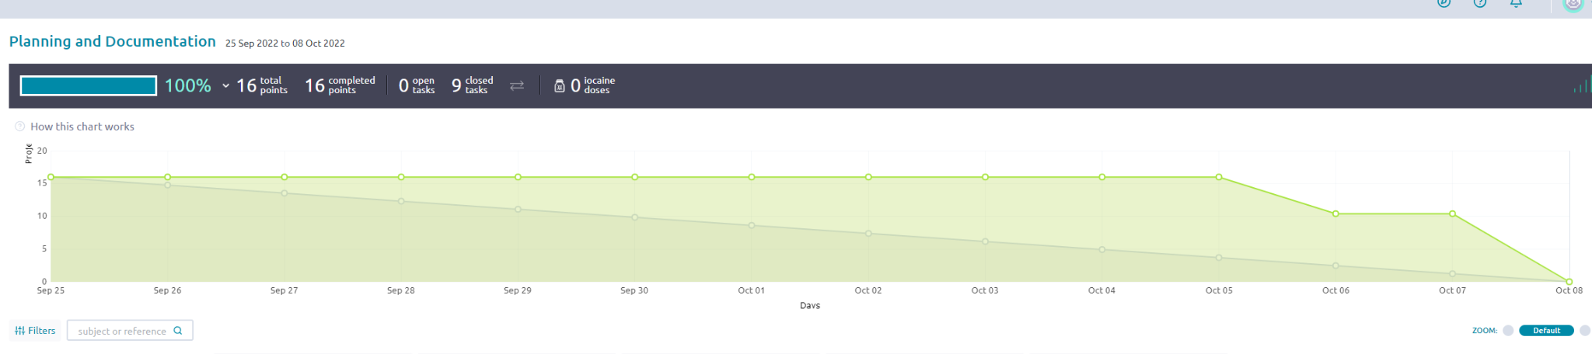

And the link: <https://tree.taiga.io/project/jlnorma4-field-day-capstone-project/taskboard/sprint-1-2328>

## Links to minutes

This is a link to our team’s standup minutes:

[Standup Minutes](https://docs.google.com/spreadsheets/d/1beFXzJNFcR82lcvSi-tIZXk3Qr86IBEQbFVrCKx_DNw/edit?usp=sharing)

This is a link to our team’s sprint planning minutes:

[Sprint 1 Planning](https://docs.google.com/document/d/1a8VBsQiQPjmNwKapy-HZGePMev7-ohwa6itcRPjPrD0/edit?usp=sharing)

This is a link to our team’s sprint retrospective minutes:

[Sprint 1 Retrospective](https://docs.google.com/document/d/1FwAVXtmWKxb-ymlwIR-ddQoLzRFKvdM5SzCCMpuc1wk/edit?usp=sharing)

Sponsor Feedback

During our meeting with the sponsor, we received feedback about the previous version of the application, in which Dr. Bateman outlined several areas that need to be addressed. One of which was the preference for a lower running cost of the application, as the sponsor is now paying at least $15/month, and would like to pay less, if possible. Another is for the recapture column of the web UI to be a “T” or “F” instead of “True” and “False” for enhanced readability. Furthermore, Dr. Bateman wanted functionality to be able to edit previous sessions from the same day, and the option to merge sessions from the Web UI if needed. Also, some quality of life improvements would be appreciated, such as form input validation occurring right when the user inputs a value instead of occurring when the user hits “Submit”.

# Feature Changes

The team will do further research to attempt to find a suitable web hosting provider that is cheaper than that in use currently. Additionally, the team will refine the UI further to address the flaws existing currently in the app.

# Technical Challenges

This is the first project report, but technical challenges the team has solved since the beginning of the class include improving overall understanding of PWAs and JavaScript as well as how to implement such technologies in various tech stacks.